**GitHub Repository:** <https://github.com/mbromberek/udacity-cloud-c03>

**Docker Repository:** <https://cloud.docker.com/u/mbromberek/repository/list>

The projects GitHub README.md has instructions for how to build and deploy the code.

The folder udacity-c3-feed-service-b contains the same code as udacity-c3-feed-service but is changed to add the text ‘B version ‘ to the start of each images comments to show it is a different version from udacity-c3-feed-service. This is only needed so can have two docker containers with different code to make it easier for testing A/B Deployment and validating the different code is being used.

Travis CI showing a successful build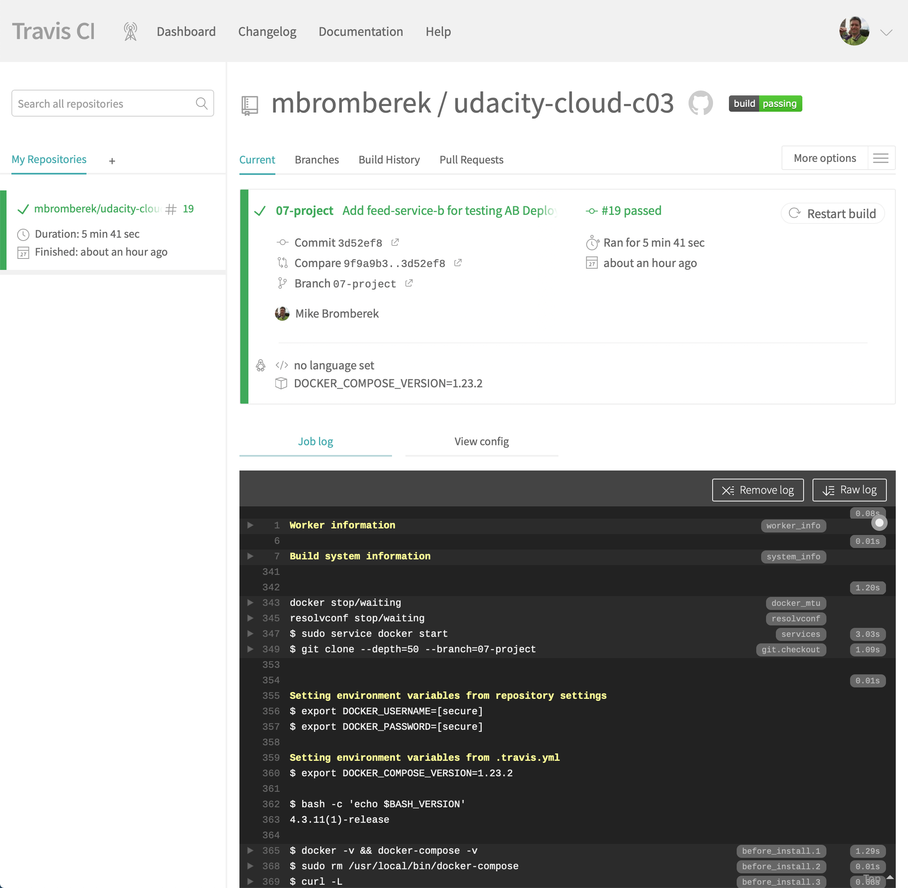

Kubernetes pods running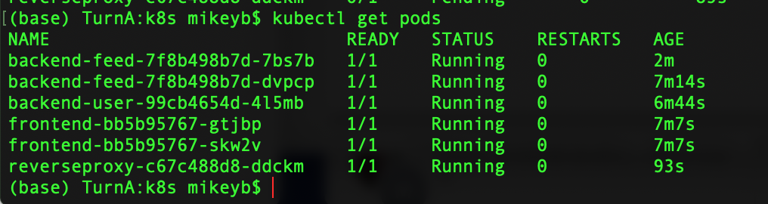

Udagram web page using regular feed version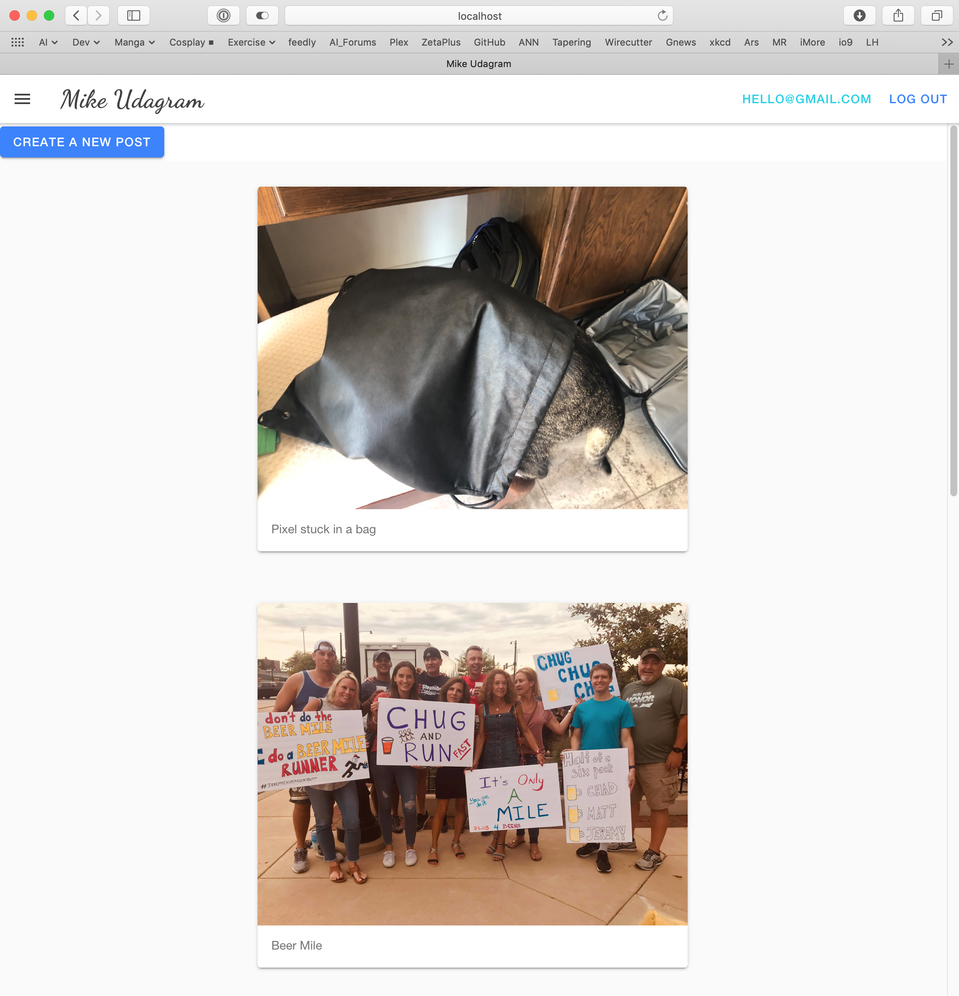

Deploy the mbromberek/udacity-c3-feed-service-b container

$ kubectl apply -f backend-feed-deployment-b.yaml

Deploy mbromberek/udacity-c3-feed-service-b to have two versions of backend-feed deployed at the same time.

Can see the backend-feed and backend-feed-b pods running at the same time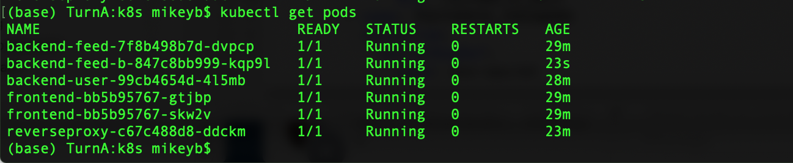

Apply the backend-feed-service-b.yaml file which will update the backend-feed service to use the backend-feed-b deployment

$ kubectl apply -f backend-feed-service-b.yaml

The Udagram page now append “B Version “ to the comments before they are shown to the user.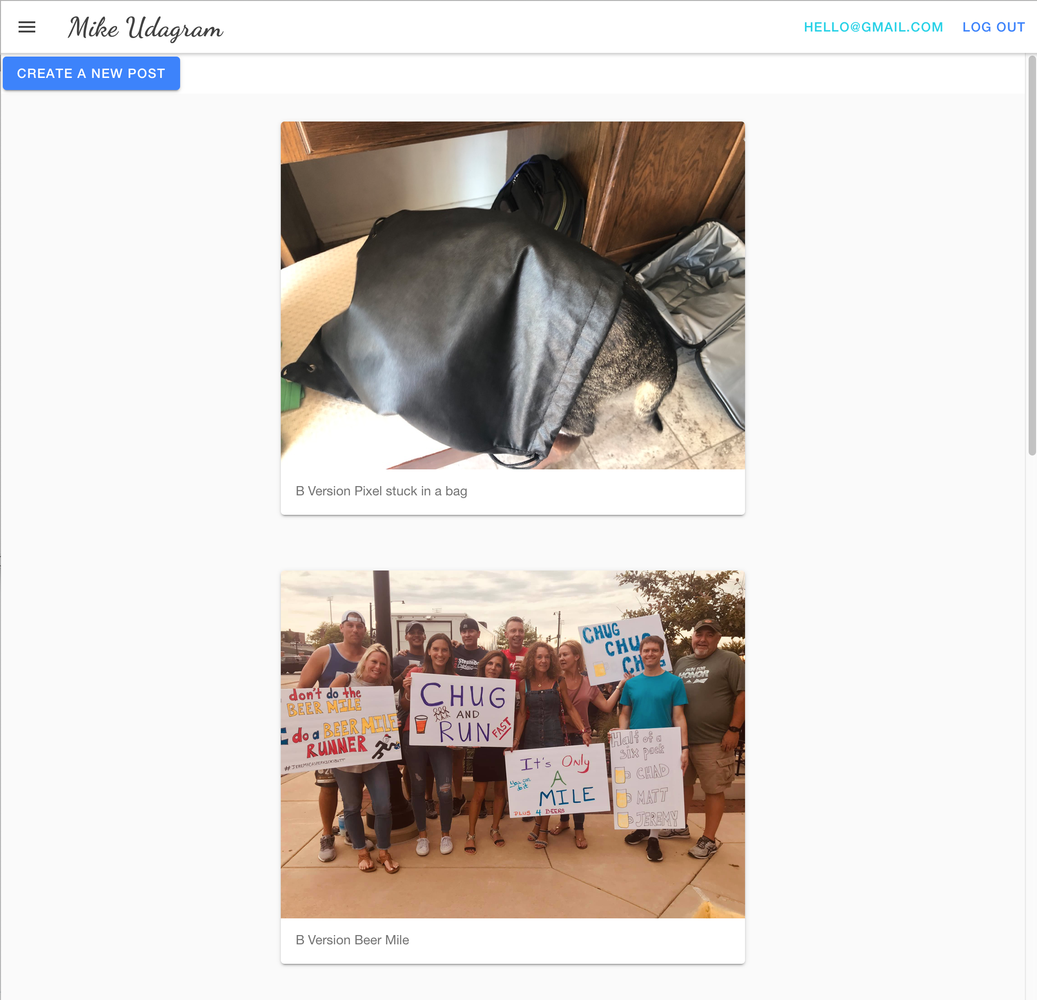

This allows either version of the code to run based on what the service is pointing to if we ned to change back to the old code.

Amazon CloudWatch Metrics for one of the EC2 Servers